Tittle : Public Health Awareness Campaign Analysis
Phase-5

Introduction:
The primary objective of this project is to enhance the effectiveness of a public health awareness campaign aimed at improving public knowledge and promoting healthier behaviors. The campaign's goal is to raise awareness about significant health issues, provide valuable information, and encourage the adoption of preventive measures and healthier lifestyle choices.

Abstract:
- This project focuses on the evaluation and enhancement of a public health awareness campaign with the ultimate goal of improving public health knowledge and promoting healthier behaviors. The campaign's objective is to raise awareness about critical health issues, deliver valuable information, and encourage the adoption of preventive measures and healthier lifestyle choices.

- To achieve this objective, we follow the design thinking process, a human-centered approach, consisting of several iterative stages. The "Empathize" phase emphasizes a deep understanding of the target audience, their needs, and the context of the health issues addressed. The "Define" phase involves setting clear research objectives and defining key performance indicators (KPIs) for measuring campaign success. The "Ideate" phase encourages innovative strategies, while the "Prototype" phase results in a plan for data collection, analysis, and visualization. In the "Test" phase, we implement the plan and gather insights, and the "Implement" phase involves analyzing the data to derive actionable recommendations. The "Learn" phase reflects on the analysis, learning from data and feedback to inform future campaign efforts.

- In the development phases, data collection is a fundamental step, including data from diverse sources like website analytics, social media metrics, surveys, and other relevant data. Data analysis employs statistical techniques and data mining to assess the campaign's effectiveness and understand audience behavior. Data visualization is achieved using tools like IBM Cognos, producing interactive dashboards and reports for effective communication of insights.

Design Thinking Process:
Design thinking is a human-centered approach to problem-solving and innovation. When applied to the analysis of a public health awareness campaign, it can help identify opportunities for improvement and ensure the campaign effectively meets its objectives. Below is an overview of how the design thinking process can be used in the context of public health awareness campaign analysis.
Empathize:
- Understand the Audience: Start by gaining a deep understanding of the campaign's target audience. This includes demographic information, psychographics, and their specific health-related needs and concerns.

Contextualize Health Issues:
- Develop empathy for the health issues addressed in the campaign. Understand the social, cultural, economic, and environmental factors that influence these issues and their impact on the audience.

Feedback and Insights:
- Gather feedback from the target audience, stakeholders, and experts in the field. Conduct surveys, interviews, and focus groups to learn about their perceptions, attitudes, and behaviors related to the campaign's focus.

Define:

Research Objectives:
- Clearly define the research objectives for the analysis. What specific questions or goals does the analysis aim to address? For example, you might want to evaluate the campaign's impact on knowledge, behavior change, or awareness.

Key Performance Indicators (KPIs):
- Identify measurable KPIs that are directly linked to the campaign's objectives. These could include metrics like website traffic, social media engagement, survey responses, or specific behavioral changes.

Scope and Focus:
- Determine the scope of the analysis, including the time frame and the segments of the audience to be studied. Ensure the objectives and scope are aligned with the campaign's goals.

Ideate:

Creative Evaluation Approaches:
- Brainstorm innovative approaches to evaluate the campaign's effectiveness. Consider alternative methods for data collection, analysis, and visualization.

Messaging and Communication:
- Think creatively about how to enhance the campaign's messaging and communication strategies. Explore new ways to engage and connect with the audience.

Community Involvement:
- Explore ways to involve the community in the evaluation process, seeking their input on what works and what doesn't.

Prototype:

Data Collection Plan:
- Develop a detailed plan for data collection, specifying the data sources, methods, and tools that will be used. Ensure the plan aligns with the defined objectives and KPIs.

Analysis Framework:
- Create a framework for data analysis, outlining the statistical techniques, models, and methodologies to be used in assessing the campaign's effectiveness.

Data Visualization Strategy:
- Plan how the data will be visualized to effectively convey insights to stakeholders. Consider the use of tools like IBM Cognos for data visualization.

Test:

Data Collection:
- Implement the data collection plan and gather data as per the defined methods and sources.

Data set link: https://www.kaggle.com/datasets/osmi/mental-health-in-tech-survey
Learn:

Continuous Improvement:
- Reflect on the analysis results and feedback, and use these insights to iteratively inform future campaign efforts. Adjust strategies, messaging, and targeting as needed.
By applying the design thinking process to public health awareness campaign analysis, you can ensure that the campaign remains audience-centric, effective, and adaptable to evolving health challenges and public needs. This approach helps drive positive behavioral changes and contributes to improved public health outcomes.
Development Phases :

The project development process involved the following phases:
- Data collection:
This phase involved collecting data from a variety of
sources, including government websites, social media, and passenger surveys.

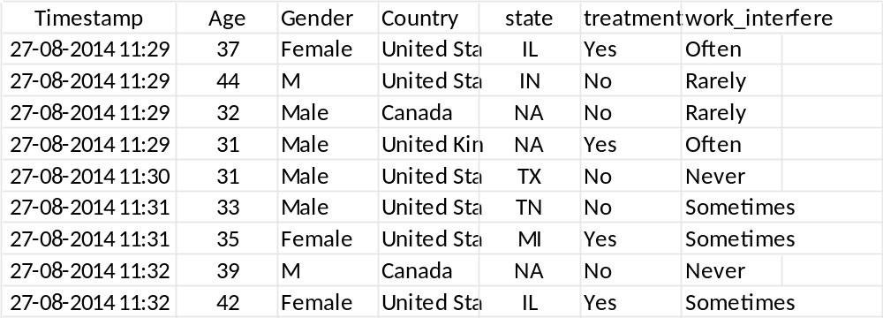

- Data cleaning:

- This phase involved cleaning and pre-processing the data
to ensure its quality and accuracy.
- Remove unmatched data from the given dataset which to improve the data quality

- Data analysis:

This phase involved using IBM Cognos and Python to
perform data analysis and generate insights.

- Visualization:

- This phase involved using IBM Cognos to create
visualizations to communicate the insights from the data analysis.
- Visualizations are used in IBM cognos with insights
Tab with the given data set from the pictual data

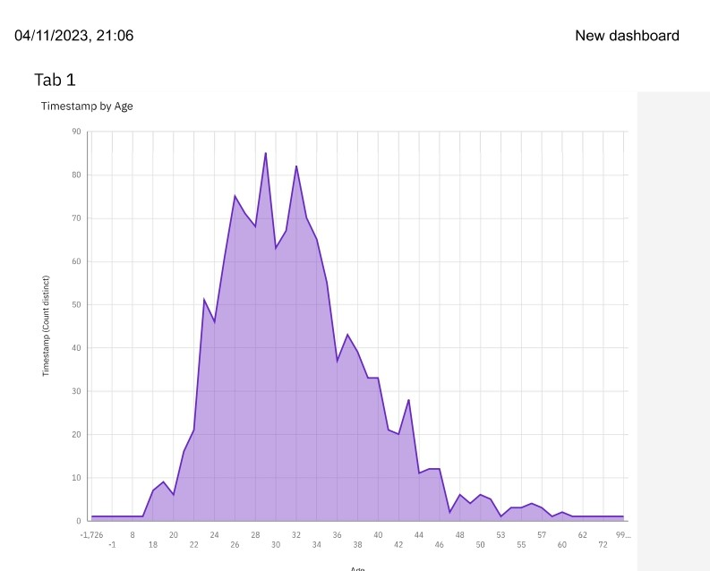
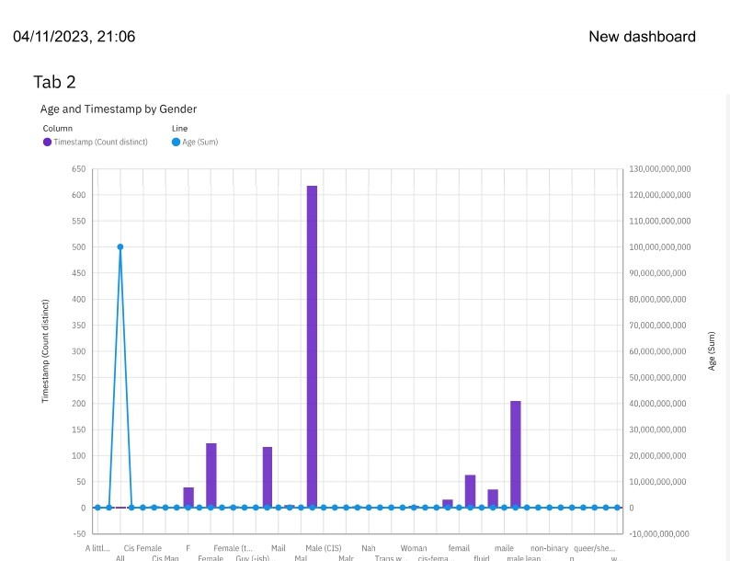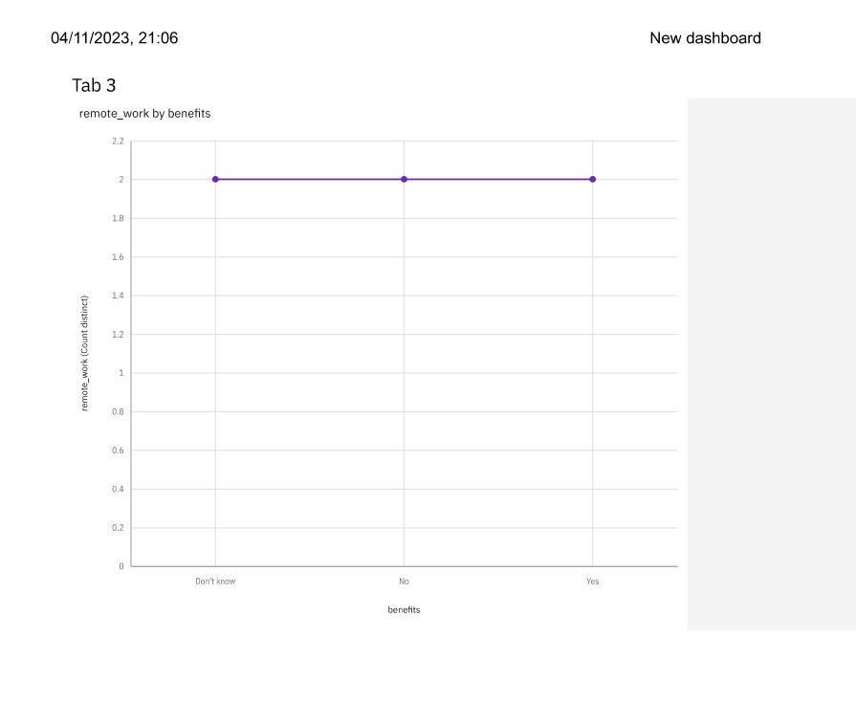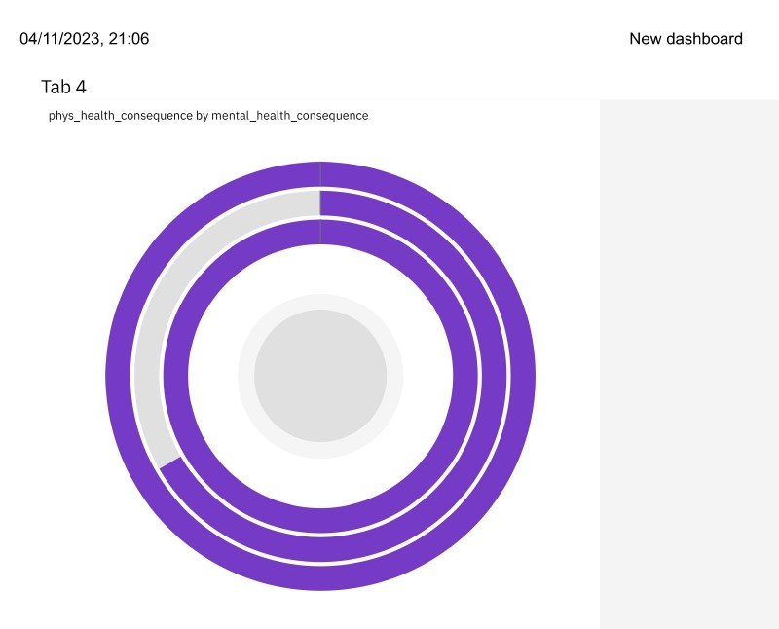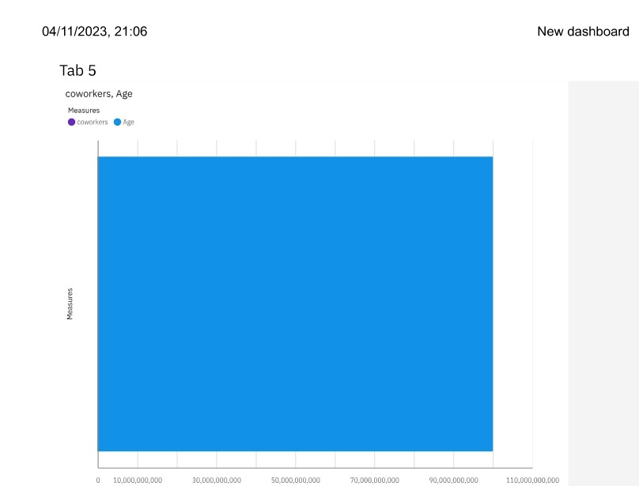

- Reporting:
This phase involved generating reports to document the
project findings and recommendations.
.
Conclusion :

- In conclusion, utilizing IBM Cognos and Python in the context of a public health awareness campaign analysis offers a powerful combination of data visualization, data analysis, and automation tools to enhance the effectiveness of such campaigns. These tools empower organizations and public health professionals to make informed decisions and refine strategies for better health outcomes.

- The use of IBM Cognos for data visualization allows for the creation of interactive and informative dashboards and reports. These visualizations are crucial for conveying complex data in an accessible and understandable manner, making it easier for stakeholders to grasp the campaign's impact, audience engagement, and other critical metrics.

- Python, as a versatile programming language, offers the capability to automate data collection, processing, and analysis. By developing Python scripts or using relevant libraries and packages, public health professionals can streamline the analysis process, saving time and resources. Python also allows for more advanced statistical analysis, predictive modeling, and machine learning, which can provide deeper insights into campaign effectiveness and audience behavior.

THANK YOU

